A picture containing clipart

Description generated with very high confidence

Azure 103 Module 2

Hands On - 12

Azure Certification Training

[**support@intellipaat.com**](mailto:support@intellipaat.com)

**+91-7022374614**

**US: 1-800-216-8930(Toll Free)**

**Azure 103 Module 2, Hands On – 12**

**Using queues with storage explorer.**

**Step 1:** Right click on Queues and click on Create Queue and enter queue name.

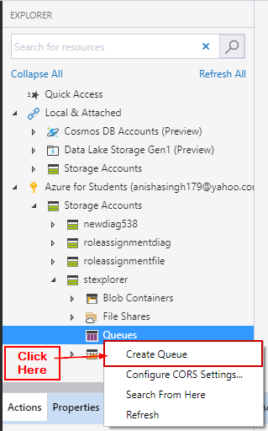

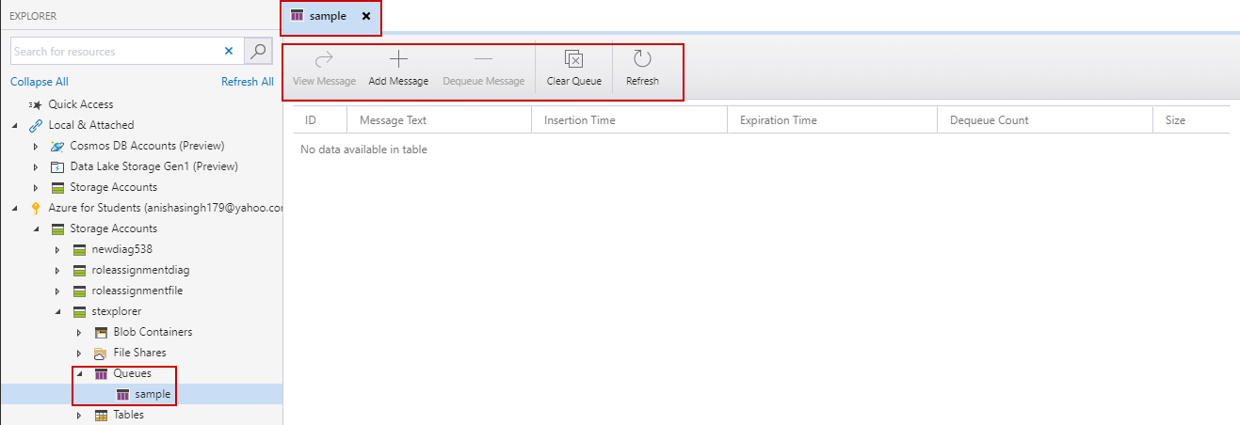

**Step 2:** Enter a sample message by clicking on Add Message, enter data and click on OK.

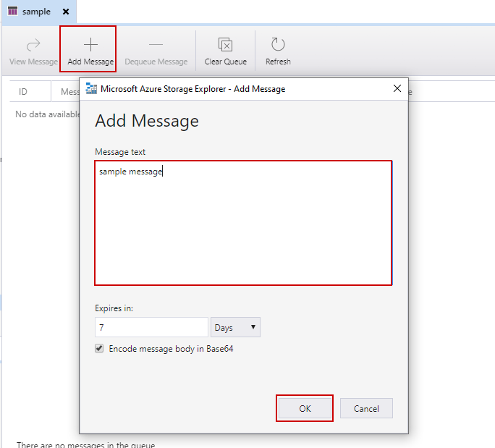

**Step 3:** The message is inserted.

